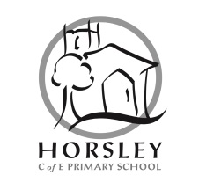
We are seeking to appoint a part-time, permanent Teaching Assistant from September, 2018. The role will involve supporting children individually and in groups, predominantly in KS1 but could involve working across the school, depending on need. The position combines 5 mornings (08:45am – 12:15pm) as a Teaching Assistant at Grade D, with 1 hour per day Midday Supervision at Grade C.
The successful applicant will need to be experienced and creative, with a positive outlook and a ‘can-do’ attitude. Working as part of a small team requires a teaching assistant who is adaptable and able to work collaboratively with members of the school and wider community. The successful candidate will also need to support the school’s distinctively Christian values. We can offer you well-behaved and motivated pupils, a happy and supportive team of staff, parents and governors who all share high expectations and aspirations for all children.
Completed application forms, and a covering letter (CVs cannot be accepted), should be sent or emailed to the school by Friday 18th May, 12:00 noon. You are welcome to visit the school; please telephone to arrange an appointment. Interviews will take place in the week commencing .
Horsley C of E (VA) Primary is committed to safeguarding and promoting the welfare of children and young people and must ensure that the highest priority is given to following the guidance and regulations to safeguard children and young people. The successful candidate will be required to undergo an enhanced DBS check.

