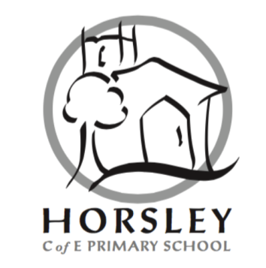
Horsley CoE (VA) Primary School
The Street
Horsley
Gloucestershire
GL6 0PU
01453 833625

admin@horsley.gloucs.sch.uk
www.horsley.gloucs.sch.uk

04 November 2021

Dear Parents and Carers
YOUNG VOICES CHOIR
Welcome to all of our new Young Voices choir members! We will be starting our weekly after-school rehearsals next Monday, 8th November, finishing at 4.00pm.
The concert takes place on Thursday 27th January 2022 in Birmingham, and we will be travelling by coach together for an afternoon of rehearsals followed by the concert itself (more details on this later in the term).
Attached to this letter are 2 order forms:
- Choir T-shirt order pack (optional – it is perfectly acceptable to wear a plain white T-shirt)
- Audience Tickets – Parent Order Form
If you wish to purchase T-shirt packs, or tickets for the concert for yourselves to watch the children perform, please complete both forms and return them to school. Payment is via Parentpay, and payment must be made by Thursday 11th November. Tickets sell out fast, so we will be ordering them on that Thursday afternoon. Tickets and T-shirt packs have to be ordered through the school – Young Voices does not accept orders directly from parents, so we must not miss this deadline!
Finally, do log on to www.youngvoices.co.uk and go to the Children’s Music Room, which your child can unlock using the code YV2021, and have full access to lots of resources to help them learn the songs and dance movements.
Thank you for your support!
Kind regards
Ms Finlow and Mrs Saddington

